**Objectives**

Create a topology using Etherchannel & VLAN’s

**Some Recommendations (as make more detailed topologies)**

* Save different versions of the topology PKT file as you work a lab, so you can go back to an earlier working one if you encounter problems: LAB7-1, LAB7-2, LAB7-3, …
* Whenever you make configuration changes do a check to ensure it works.
* Make a default PKT file that is just PC’s (PC1, PC2, PC3, etc) with IP addresses configured. Used as a start whenever you create a new topology.

**A - Create the Topology** 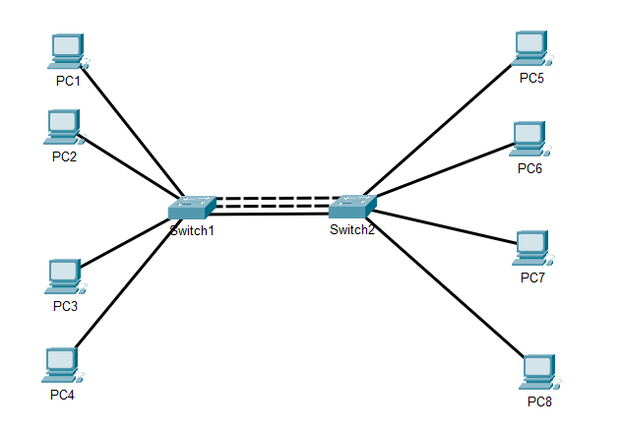

* Name (via CLI) each switch: SWITCH1 and SWITCH2
* Connect PC1 to Port1, PC2- Port 2, …, PC5 to Port5, PC6 to Port 6, etc
* Assign IP addresses: PC**1**=192.168.10.**1**, PC**2**=192.168.10.**2**,
* Connect switches : G0/1-G0/1, G0/2-G0/2, F0/24, F0/24  
  *Note: You should see two of the three connections disabled via STP*
* Create an Etherchannel grouping all Gigabit Ethernet cables   
  *Note: You should see only one of the three connections disabled via STP*

**B - Create the VLANs and Verify**

* Create VLAN 100 for PC1, PC2, PC5, and PC6 – Name it *yourname_100*
* Configure port F0/24 on each switch for VLAN 100 only   
    
  *Note:* At this point all switch-switch connections should be enabled.  
   Enter “SHOW VLAN” to see why.
* Create VLAN 101 for PC3 and PC7 – Name it *yourname_101*
* Create VLAN 102 for PC4 and PC8 – Name it *yourname_102*
* At this point only pinging VLAN 100 devices will work. For full topology functionality we need to set the Etherchannel to Trunk Mode:  
    
  Switch#**config t**

Enter configuration commands, one per line. End with CNTL/Z.

Switch(config)#**int p01**

Switch(config-if)#**switchport mode trunk**

* At this point your topology should have full functionality. PC’s in each VLAN should be able to ping each other. (PC1 can ping PC2, PC5 and PC6; PC3 can ping PC7; PC4 can ping PC8).

**C – Additional Topics**

* Set the timezone for each switch to EST which is 5 hours less than universal time.
* Turn off CDP notification for all unused interfaces on Switch1   
  *Note: the command “SHOW CDP INTERFACES” will display the CDP status for all   
   interfaces currently enabled.*

**Lab Completion**

* Add a textbox and detail ALL the new commands learned in Module 6. Include the commands in the PPT not just the commands in this lab!
* Save your PKT file : L06-lastname.PKT.
* Submit only the PKT file in Ilearn.

**** End of Lab ***